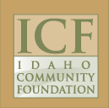
http://www.idcomfdn.org/Scholarships

For seniors at and graduates of Salmon River High School in Riggins with a minimum 3.0 GPA and planning to attend a higher education institution as a fulltime undergraduate student. Preference may be given to applicants seeking a degree in Business Marketing or a degree related to Forest Products and Wildlife Resources. Deadline is April 1. Click here to apply.

