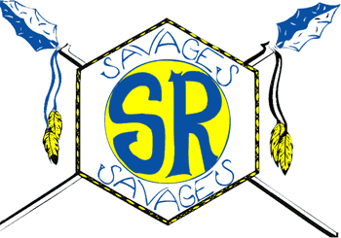
Salmon River High School
2018-2019

Student Fees
Class Fee $20.00
Includes Class fee - $15.00
ASB fee - $5.00
and Activity Card
Jr. High Athletic Fee – Must be paid by 1st game
Football $20.00
Volleyball $20.00
Basketball $20.00
Track $20.00

Varsity Athletic Fee – Must be paid by 1st game
Football $30.00
Volleyball $30.00
Basketball $30.00
Track $30.00

Yearbook $30.00
Must be paid by May 1
BPA Dues $30.00

Calculator Use Fee
for higher level classes only
(Alg. II, Calculus, Trig, etc.) $20.00
Optional Hall Lock Fee $6.00

Make checks for fees payable to SRHS and checks for lunch payable to SR JSD 243.
Print student’s full name in the memo field of your check.
Checks must be for the EXACT amount of purchase.

School Lunch
Breakfast FREE

Reduced Lunch $0.40
1st Qtr $14.00
2nd Qtr $14.80
3rd Qtr $14.00
4th Qtr $14.00
1st Sem $28.80
2nd Sem $28.00

Full Price Lunch $2.40
1st Qtr $84.00
2nd Qtr $88.80
3rd Qtr $84.00
4th Qtr $84.00
1st Sem $172.80
2nd Sem $168.00

Adult Lunch $3.8

