Science Fair
2014 Project Guide

Student Science Fair Project Schedule

Assignment | Assignment Description | In Class Due Date
Science Fair Application | Approval Form signed by the parents | 1/18/2014
Topic Selection Wizard | Please have your students log in to complete the Topic Selection Wizard (“Wizard”) to help them narrow down an area of interest for their science fair project. | 1/18/2014
Question | The specific question the student will be investigating in the science fair project. | 1/18/2014
Research Paper & Bibliography | The Research Plan is a roadmap of the research questions that need to be answered. The Bibliography is a list of the sources that will be used to answer the research questions. Source Requirement: at least 3 offline sources. | 2/06/2014
Research Paper | The purpose of the Research Paper is to provide information to help understand why the experiment turns out the way it does. It should include:  - The history of similar experiments or inventions.  - Definitions of all important words and concepts that describe the experiment.  - Answers to all the background research plan questions.  - Mathematical formulas, if any, that are needed to describe the results of the experiment. | 2/27/2014
Variables and Hypothesis | An explanation of which factors will be changed while conducting the experiment and a hypothesis on the resulting impact of the change. | 2/27/2014
Materials and Procedures | A detailed list of the materials that will be used to conduct the experiment and the detailed steps that will be followed while conduct the experiment | 2/27/2014
Conducting the Experiment | . Minimum Trials: 3 runs of experiment. If students are working with plants, they should have 3 plants for each variable tested. | 3/3/2014
Data Analysis and Graphs | The analysis of the experimental data. A summary of the findings of the experiment. | 3/10/2014
Conclusions | An explanation of the results of the experiment. | 3/10/2014
Final Report | A report that collects all the above written assignments in one place plus a short abstract of the project. | 3/10/2014
Display Board and powerpoint | The final project board that will be displayed at the science fair and digital presentation will be given by the student. | 3/13/2014
School Science Fair | The date the students must turn in their projects to the teacher or to the school science fair. | 3/17-18/2014
Visit the Fair! | Parents may visit the science fair at this date and time. | 3/17-18

Please contact Mrs. Walters if you have any questions: 208-628-3431 or walterss@jsd243.org

SCIENCE PROJECT STEPS

1. Choose a topic. Be sure it interests you. Don’t pick one because you think it will be easy. Talk it over with your parents and when you have decided, inform your teacher, and do not ask to change your topic later. Get your Registration form for your teacher signed by your parent and turn it in.

2. State your purpose as a question. What is it that you want to find out by doing this project?

3. Research your problem. Look at any books/websites that might help you, make observations by simply looking at things, talk to people, and find out as much as possible about your topic. Write down any ideas you have and where you got them. Also, keep note of all information needed for citing your resources.

4. Form a hypothesis. What do you think is going to happen? Based on what you know or found out from step #3, what do you think the results of your experiments will be? After doing the experiments, it may turn out that your guess was wrong. It is okay if this happens.

5. Plan your project. How will you test your hypothesis? What experiments will you do? How will you measure the results? Where will you keep your information? Be sure to keep notes and write down everything you do and what happens.

6. Collect all your materials. Find a place to keep things where others won’t bother them. Let other family members know what you are doing so they do not throw your materials away by mistake.

7. Conduct your experiments. Remember, the more times you do an experiment the more reliable and accurate the results will be. Do each experiment at least three times and get an average of the results for your graph. Use something to measure your experiments: a ruler or yardstick if you are measuring distance, a clock to measure time, etc. Check the measurements to be sure you are correct.

8. Record your data. As you do your experiments, you will want to write down what you saw or found out. Organize this information in an orderly manner. Put the date, time, and any other useful information. Write your measurements clearly.

9. Draw conclusions. What did you learn from your experiments? Have you proved or disproved your hypothesis? You made a guess about what you thought would happen. Now tell what really did happen. You don’t lose points if your guess turned out to be wrong.

10. Prepare your titles, charts, graphs, drawings, and diagrams. Make them large enough to see, neat, and colorful.

11. Construct your science fair display. Get your cardboard display board from your teacher so you can show all your work and have your hands free to point to sections when you give your presentation.

12. Prepare and practice your presentation. Be able to tell about what you used what you did in your experiments, and what you found out. Know it well enough that you don’t have to read it from the display.

13. Plan a time line so you don’t leave everything until the last minute. If you need help, tell your parents and your teacher, the earlier the better.

14. Relax and enjoy yourself. You will do a GREAT job!
SCIENCE FAIR RULES
Aw!, you mean there are rules? Of course there are, silly, this is made by adults!

1. Number one rule. . . think safety first before you start. Make sure you have recruited your adults to help you.

2. Never eat or drink during an experiment and always keep your work area clean.

3. Wear protective goggles when doing any experiment that could lead to eye injury.

4. Do not touch, taste, or inhale chemicals or chemical solutions.

5. Respect all life forms. Animals are not allowed to be used in experiments. Do not perform an
experiment that will harm a person.

6. All experiments should be supervised by an adult.

7. Always wash your hands after doing the experiment, especially if you have been handling chemicals.

8. Dispose waste properly.

9. Any project that involves animals, drugs, firearms, or explosives are NOT permitted.

10. Any project that breaks district policy, and/or local, state, or federal laws are NOT permitted.

11. Use safety on the Internet! NEVER write to anyone without an adult knowing about it. Be sure to let
an adult know about what websites you will be visiting, or have them help you search.

12. If there are dangerous aspects of your experiment, like using a sharp tool or experimenting with
electricity, please have an adult help you or have them do the dangerous parts. That’s what adults are
for so use them correctly. (Besides, it makes them feel important!)

Science Fair Project Approval Form
Salmon River High School
Mrs. Walters

Name________________________________ Period_________________

Question/Problem:___________________________________________________________________________________________________________________________
Independent Variable:____________________________________________

Dependent Variable:__________________________________________________

Constants – Brainstorm a list of potential interfering factors that you will need to control to maintain a controlled experiment.

Control Group – Describe your unaltered test group. If you don’t think a control group is relevant to your experiment, explain why.

Procedure – Briefly describe the general idea of your experiment

Background Research – Brainstorm some ideas about what you need to research at the library in order to make a valid prediction about what should happen in your experiment.

Planning – Please indicate whether you have discussed the following issues with your parent(s)
or guardian(s).

YES NO Cost and availability of materials required for this project

YES NO Feasibility of the project within the given timeframe

YES NO Special requirements associated with your topic (see “Choosing Your Topic”) including access to parent supervision, qualified scientists, etc

YES NO Project timeline

Signatures – All three signatures are needed before beginning research.

Student:______________________________

Parent/Guardian:_______________________________

Mrs. Walters:__________________________________

The Written Report

All students in grades 6-10 must include a written report as part of their science fair project. The completed report should be in a folder and presented with the science fair project.

The report should include the following:

1. Title Page - Center the title of your project and give the problem/purpose if it is different from your title. Also include your name, grade, school, and teacher.
2. Acknowledgements - Acknowledge or thank any person (parents, sisters or brothers, a teacher, a scientist, a doctor, or a company) that helped you with your project. The Acknowledgements page should come after the Title page.

3. Table of Contents – List the order and page numbers of each part of your report.
4. Abstract- Give a three-paragraph summary of the project. Paragraph one- State the problem/purpose of the experiment and your hypothesis. Paragraph two- Summarize the procedures. Paragraph three- Summarize your results and state your conclusion.
5. Research - This is background information about your topic. You should look in science books, magazines, and use reliable Internet resources. This part can be 1 – 5 pages long.
Invention Project: Brainstorm as many possible solutions as you can. Imagine different set-ups or designs. Compare and talk about the positive and negative points of each idea. Do not just try your first idea, but choose the best one. Reach consensus on which idea is the best possible solution. Create a plan. Draw a diagram and label the parts of your diagram. Use symbols to label the parts. Make a list of the materials you would like to use for your invention and the amounts you will need.
6. Hypothesis - Tell what you predict will happen in your experiment. Remember to state your independent and dependent variables in your hypothesis. If I change _______ then _________ will happen.
For Invention Project: Tell the purpose of the project
7. Materials and Procedure – List the materials needed in the experiment. Then identify the manipulated and responding variables and list the variables that you controlled or held constant. Write the steps (the directions) for doing the experiment.
Invention Project: V. PLAN & CREATE
A. Diagram: Make a plan. Draw a diagram and label it so that other people can understand your design.
B. Materials: List the materials, including amounts, you will need for your invention. As you collect the materials, consider how you might borrow, make, or use inexpensive materials.
C. Build: Build your invention according to your “plan.”
D. Obstacles: Keep a log of difficulties you run into and how you address them
8. Results - Write down what happened in the experiment. Make charts or graphs and include them in the report folder. These may be smaller than the ones you put on your poster display.
9. Conclusion - Answer the problem and explain what you found out. Tell if your hypothesis was correct or incorrect. (It’s okay if your hypothesis was incorrect.)
10. Reference List - (Bibliography) List the books, magazines and Internet sites that you used in your research.

Basic Outline for Science Fair Research Paper

This is where you will explain background information on your topic. Ask why thing happen, ask how thing happen, ask what causes things to happen, ask what are the properties of key substances.

A great list of questions you can answer is at the following website.
http://www.sciencebuddies.org/science-fair-projects/project_background_research_plan.shtml#makingabackgroundresearchplan

Introduction –

State your question “What is the relationship between X & Y? (Independent and dependent variables)

Explain why you picked this question and why it is important to you or other people.

Section 1 –

Summarize and explain the information that you discovered about one of the two parts to your question. (X)
- At least one paragraph per source

Explain how this research helps answer your question.

Section 2 –

Summarize and explain the information you discovered about the second part of your question. (Y)
- At least one paragraph per source

Explain how this research helps answer your question.

Section 3 –

Tell me your hypothesis

Summarize the facts from your research that lead you to your hypothesis.

Closing Paragraph –

Summarize the two main points you researched (II. and III. above)

Restate your hypothesis.

Example Questions include:
What is the history of my experiment
Who discovered/was given credit for discovering it?
How does it work? (Define vocabulary words)
How has it changed over time?
Why does this happen?
What does this impact?

Here is a link to an online outline maker.
http://www.crlsresearchguide.org/NewOutlineMaker/NewOutlineMakerInput.aspx
Online Bibliography maker:
http://education.bluevalleyk12.org/KidBib/
A great Place to find resources is:
http://lili.org/

Resource Form:
The number of resources needed will be determined by your grade.
You must submit this for each resource used.

Type of Resource: _______________________________________________
Website: http://________________________________________________

Author: ______________________________________________________
Title: ________________________________________________________
Publishing Company: ___________________________________________
Location of the Publishing Company: ______________________________
Date of Publication: ____________________________________________

Information found in your own words:
(Must be at least one paragraph summary.)
___________________________________________________________________
___________________________________________________________________
___________________________________________________________________
___________________________________________________________________
___________________________________________________________________
___________________________________________________________________
___________________________________________________________________
___________________________________________________________________
___________________________________________________________________

Display Board

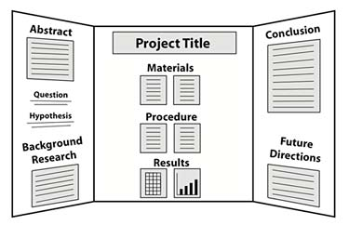

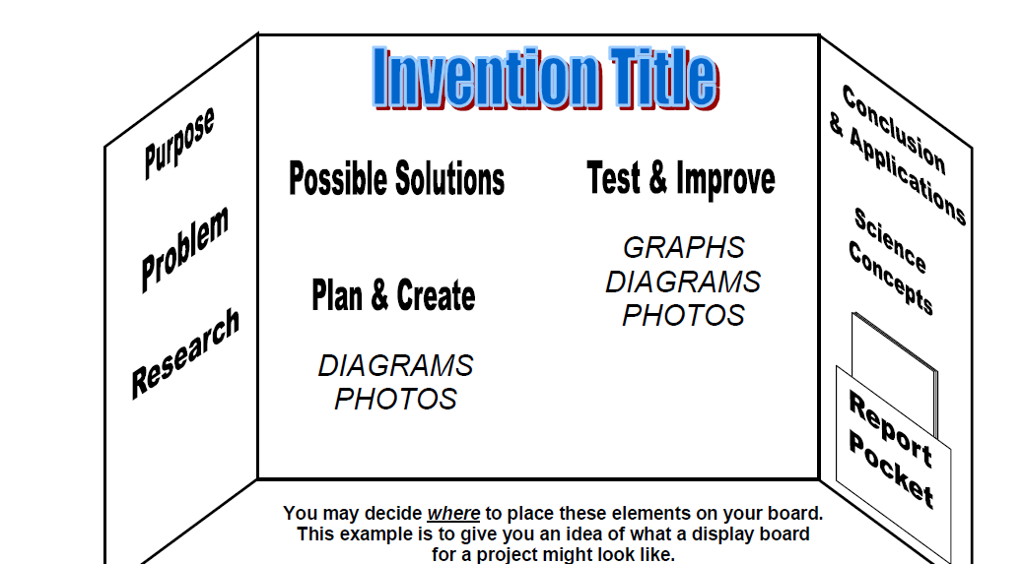

Digital Presentation

See Template on Website
