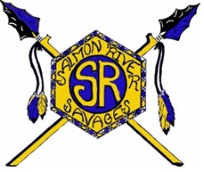
Salmon River High School Transcript Request Form

Instructions:

- Completely fill out the transcript request form and mail or deliver it to:
Salmon River High School

PO Box 872 Or
Riggins, ID 83549 Fax Requests to: 208-630-6026
Email Requests to: cereghinos@jsd243.org

- NO VERBAL requests will be processed.
- No requests will be processed June 10 through August 15.

Date ___________ Birthdate ____/____/____

Name __________________________________ Number of Transcripts Requested ___________
(Please Print Clearly)

Send to ______________________________
When did you graduate? ____________________
Attention _____________________________
OR last attended Salmon River High School?
________________ to ________________ Address ______________________________

Previous/Maiden City/State/Zip __________________________
Name __________________________________

Phone number ___________________________

Address ________________________________ Send Transcript(s)

City/State/Zip ____________________________ _____ Immediately

_____ Hold transcript for pickup by requestor
Type of Transcript needed:

_____ Hold for pickup to be picked up by:
_____ Personal
_____ NCAA #__________________________ _____________________________________
_____ Official for Employment Name (Please Print Clearly)
_____ Official for College (ID required to pick up)
_____ Scholarship (sealed) # _______________
_____ Military

Student Signature ___________________________________________Date___________________

FOR OFFICE USE: Date Request Received: __________________ Date Transcript Sent: __________________

