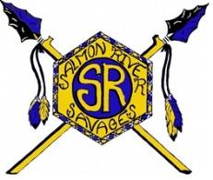
Salmon River Jr/Sr High School
New Student Credit/Testing Information

Student Name:________________________________ Grade:_______
Were any 7th or 8th grade classes taken for high school credit? ☐ Yes ☐ No

Please indicate the most recent State Assessment that the student has taken in middle school or high school.

English Language Arts assessment:
Grade level:__________ State:_______________
(Example: 8th grade, Idaho)

Math assessment:
Grade level:__________ State:_______________

Science assessment:
Grade level:__________ State:_______________

Has the student taken an End of Course (EOC) assessment after 10th grade for:
Biology? Yes No Chemistry? Yes No
Civics? Yes No

Has the student taken an SAT or ACT? Yes No
Year:_________ State:_______________

