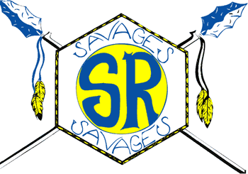
Salmon River High School
2021-2022

Student Fees
Class Fee $20.00
Includes Class fee - $15.00
ASB fee - $5.00
and Activity Card
Jr. High Athletic Fee – Must be paid by 1st game
Football $20.00
Volleyball $20.00
Basketball $20.00
Track $20.00

Varsity Athletic Fee – Must be paid by 1st game
Football $30.00
Volleyball $30.00
Basketball $30.00
Track $30.00

Yearbook $30.00
Must be paid by May 1
BPA Dues $30.00

Calculator Use Fee
for higher level classes only
(Alg. II, Calculus, Trig, etc.) $20.00
Optional Hall Lock Fee $6.00
Make checks for fees payable to SRHS and checks for lunch payable to SR JSD 243.
Print student’s full name in the memo field of your check.
Keep your receipt for verification of payment.
Checks must be for the EXACT amount of purchase.
School Meals
Breakfast FREE

1st Lunch FREE
2nd Lunch $4.00

Adult Lunch $4.00

