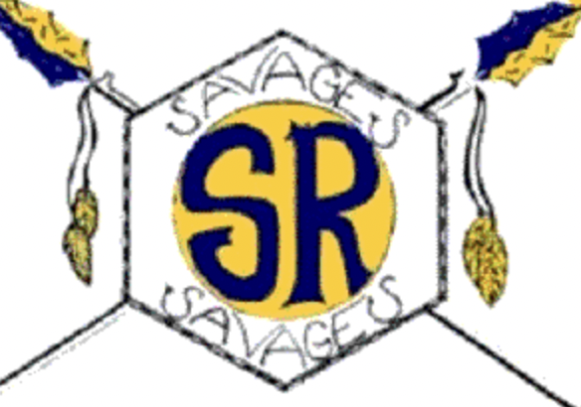

Salmon River High School
JH Basketball 2022

Date | JH Basketball Games | Game Time | Girls | Boys | Bus
Mon. 1/24 | Council | 4:30 pm |  |  | *****
Wed. 1/26 | Meadows Valley | 4:30 pm |  |  | 3:00 pm
Mon. 1/31 | Tri-Valley | 4:30 pm |  |  | 2:00 pm
Thurs. 2/10 | Cascade | 4:30 pm |  |  | 2:00 pm
Fri. 2/11 | Tri-Valley | 4:30 pm |  |  | *****
Fri. 2/25 | Cascade | 4:30 pm |  |  | *****
Mon. 2/28 | Meadows Valley | 4:30 pm |  |  | *****
Wed. 3/2 | Council | 4:30 pm |  |  | 2:30 pm
Fri. 3/11 | Girls Tourney @ Council | TBD
Sat. 3/12 | Boys Tourney @ Council | TBD

Bold Games = Home

The schedule is subject to change, please be aware of any changes to the game schedule and talk with the administration, coaches and parents.

Girls Coach - Levi Tucker
Boys Coach - Mike Shepherd
Principal - Kyle Ewing
Athletic Director - Brittany Priddy
Superintendent - Jim Doramous

